Abstract
The HIT Canteen Digital Payment and Meal Verification System is a web-based prototype developed to modernize meal payment, ordering, and verification processes within a university canteen environment. The system was designed in response to challenges associated with manual cash handling, slow payment confirmation, long service queues, weak transaction traceability, and limited administrative oversight. The prototype introduces a role-based digital platform for students, staff members, and administrators.
Students use the platform to register, verify their email addresses, fund digital wallets, browse meals, place orders, make payments, and generate QR-based meal tickets. Staff members use the system to manage meals, verify purchases through QR scanning, process walk-in orders, and top up student wallets using cash at the counter. Administrators use the dashboard to monitor users, transactions, reports, food items, and system settings. The system integrates secure authentication, wallet ledger accounting, QR-based ticket validation, payment transaction logging, and reporting functions.
The prototype was implemented using Django and Django REST Framework on the backend, with responsive HTML, CSS, and JavaScript on the frontend. Supporting technologies include Paynow integration for online top-ups, QR code generation and scanning tools, and SQLite for persistence during development. The report presents the system background, architecture, design decisions, implementation approach, user interfaces, testing, and user guidance. The prototype demonstrates that a digital canteen platform can improve efficiency, security, accountability, and convenience for all users within the HIT canteen environment.

1. Introduction

1.1 Background to the System
University canteens serve a large number of students and staff within limited time periods, especially during breakfast, lunch, and supper hours. At the Harare Institute of Technology canteen, the problem started when students noticed an opportunity to commit fraud through ticket duplication due to the lack of unique and secure tickets. Since the existing ticket system does not have strong verification controls, it becomes difficult for staff to confirm whether a ticket is original, reused, or duplicated. This creates a risk of revenue loss, poor accountability, and weak control over meal distribution.
In addition, the increasing enrolment of HIT students has placed more pressure on the canteen’s existing payment and verification system. In many cases, meal payment and verification are still managed through manual processes that depend heavily on cash, verbal confirmation, physical tickets, and paper-based tracking. These methods often lead to long queues, delays in service delivery, frustration among students, weak accountability, and difficulty in monitoring daily canteen operations. During peak hours, staff may also struggle to verify tickets quickly and accurately, which increases the chances of errors and possible fraud.
Another major challenge is poor forecasting of daily food demand. The current ticket system does not provide accurate real-time data on how many students are expected to consume food on a particular day. As a result, the canteen may prepare excess food, leading to wastage, or prepare too little, resulting in food shortages. This affects both operational efficiency and student satisfaction because some students may fail to access meals on time or may not get food at all.
The HIT Canteen Digital Payment and Meal Verification System was developed as a prototype to address these problems. The system introduces a structured digital environment in which students can manage meal payments electronically, staff can verify purchases quickly, and administrators can monitor the overall operation using a central dashboard. Through digital payment records and electronic meal verification, the system helps reduce ticket duplication, improve accountability, shorten queues, and support better decision-making in food preparation.
The design of the prototype aligns with the institutional need for more efficient service delivery and better financial control in campus operations. It also supports improved record keeping, easier monitoring of daily transactions, better demand forecasting, and enhanced transparency in the management of canteen services. Therefore, the system provides a practical solution to the challenges caused by manual ticket-based processes at the HIT canteen.

1.2 Problem Statement
The traditional canteen process is inefficient because it depends on manual cash handling, slow payment verification, and fragmented record keeping. Students may experience delays while making payments or collecting meals, staff may struggle to verify whether a meal has already been paid for, and administrators may have limited visibility into transaction flows, meal demand, and service performance. These issues reduce service efficiency and create opportunities for fraud, duplication, and poor financial accountability.

1.3 Functional Objectives of the Prototype
The functional objectives of the prototype are:
To allow users to create accounts and log in based on their system roles.
To allow students to verify their accounts through email confirmation.
To allow students to fund their wallets and manage digital balances.
To allow students to browse available meals and place meal orders.
To generate QR meal tickets after successful payment.
To allow staff members to scan and verify student QR meal tickets.
To allow staff members to process walk-in orders and cash wallet top-ups.
To allow administrators to monitor transactions, users, food items, reports, and settings.

1.4 Non-Functional Objectives of the Prototype
The non-functional objectives of the prototype are:
To provide a user-friendly and responsive interface across phones, tablets, and laptops.
To improve security through email verification, role-based access control, and QR validation.
To ensure transaction traceability through logs, wallet ledger entries, and payment records.
To support reliable performance during peak canteen usage periods.
To provide a maintainable design using clear modules and structured backend services.

1.5 Scope of the System
Scope of the System
The scope of the system covers the main activities involved in managing digital meal payments, meal ordering, and meal verification at the HIT canteen. These activities include student registration and login, wallet funding, digital ordering, QR ticket generation, QR ticket validation, meal management, staff-assisted wallet top-ups, walk-in order handling, administrative reporting, and settings management. The system is designed to support the daily operations of the canteen by replacing most manual ticket-based processes with a more secure and efficient digital process.
The student side of the system allows students to create accounts, log in securely, view available meals, fund their digital wallets, place meal orders, and receive QR-based tickets after successful payment. Each QR ticket acts as proof of purchase and is linked to a specific student, meal, date, and transaction. This helps reduce the risk of ticket duplication because every ticket can be validated electronically before a meal is issued.
The staff side of the system supports canteen employees in handling meal verification and customer service activities. Staff members can scan or validate QR tickets, confirm whether a ticket is valid, used, expired, or invalid, and then issue meals accordingly. The system also allows staff to assist students with wallet top-ups and process walk-in orders for students who may not have ordered in advance. This makes the system flexible enough to support both planned digital orders and physical canteen interactions.
The administrative side of the system provides tools for managing meals, users, prices, wallet transactions, orders, and reports. Administrators can add, edit, or remove meals, update meal availability, monitor daily sales, track the number of meals ordered, and generate reports that support decision-making. These reports can help the canteen estimate demand, reduce food shortages, minimize food wastage, and improve financial accountability.
The prototype focuses specifically on the operational needs of the Harare Institute of Technology canteen. It is implemented as a web-based system with responsive user interfaces, meaning it can be accessed using computers, tablets, and mobile phones. This makes it suitable for students, staff, and administrators who may use different devices during daily canteen operations.
However, the system is limited to internal canteen operations and does not include external food delivery, supplier management, payroll processing, advanced inventory control, or full integration with external accounting systems. It mainly focuses on improving payment efficiency, reducing ticket fraud, supporting fast meal verification, shortening queues, improving reporting, and strengthening control over meal distribution within the HIT canteen environment.

1.6 Limitations of the Prototype
The prototype has several limitations. First, it is not yet deployed as a full production system. Second, live online payment behavior depends on third-party gateway availability and configuration. Third, the system was built around the needs of one institutional canteen, meaning broader multi-campus deployment would require additional scaling and policy features. Finally, while the prototype includes core reporting and monitoring tools, advanced analytics and deeper forecasting can still be expanded.

1.7 Organization of the Document
This report is organized into the following sections: Introduction, System Overview, System Architecture and Design, Technologies and Tools Used, System Implementation, User Interface Design and Screenshots, System Testing and Evaluation, User Guide, Discussion, and Conclusion.

2. System Overview

2.1 General Description of the System
The HIT Canteen Digital Payment and Meal Verification System is a role-based web application that supports three main types of users: students, staff, and administrators. The system digitizes the payment and meal collection lifecycle from account creation to payment verification. It combines wallet-based transactions, QR ticketing, staff-assisted functions, and administrative control tools into one platform to improve efficiency, accountability, and control within the HIT canteen.
Students use the system to register accounts, log in securely, view available meals, fund their digital wallets, place orders, and receive QR tickets after successful payment. Each QR ticket is linked to a specific transaction, student account, meal item, and date of purchase. This makes it easier to confirm whether a meal has already been paid for and reduces the risk of duplicated or reused tickets.
Staff members use the system to support day-to-day canteen operations. They can validate QR tickets during meal collection, confirm whether a ticket is valid, expired, already used, or invalid, and assist students with wallet top-ups where necessary. The system also supports walk-in order handling, allowing staff to serve students who may not have placed orders in advance while still maintaining proper digital records.
Administrators have access to management and monitoring functions. They can manage meals, update prices, control meal availability, view users, monitor orders, track wallet transactions, and generate operational reports. These reports help the canteen understand daily demand, monitor sales, identify peak periods, reduce food wastage, and improve planning for future meal preparation.
The system also strengthens financial control by creating a clear digital record of payments and meal collections. Unlike manual ticket systems, where records can be lost, duplicated, or difficult to verify, the digital platform provides traceable transaction histories and centralized monitoring. This improves transparency and supports better decision-making by canteen management.
Overall, the HIT Canteen Digital Payment and Meal Verification System provides a structured and reliable solution for managing canteen services. It reduces dependence on manual tickets, shortens queues, limits fraud opportunities, improves meal verification, and supports more accurate reporting within the HIT canteen environment.

2.2.1 Core Functions
- User registration and email verification.
- Secure login and role-based access for students, staff, and administrators.
- Meal listing, selection, and ordering.
- Pickup slot selection for meal collection.
- QR meal ticket generation after successful payment.
- Walk-in order service for non-prebooked customers.
- Admin reporting and analytics.
- Audit tracking and fraud alert support
2.2.2 System Features
- Role-based dashboards for different users.
- Digital wallet for cashless meal payments.
- Transaction history for payments, top-ups, and orders.
- Meal catalogue showing meals, prices, and availability.
- Pickup slot feature to reduce queues.
- Unique QR code ticket for each paid order.
- Ticket validation to prevent duplication and reuse.
- Reports showing sales, orders, and demand trends

2.3 Intended Users

Students
Students use the system to register and create personal accounts, verify their email addresses, and log in securely to access the student portal. After logging in, they can fund their digital wallets through available top-up options and use the wallet balance to pay for meals electronically. The system also allows students to browse the available meals, check prices, view meal availability, select preferred pickup slots, and place orders without relying on physical tickets.
After a successful order, the system generates a unique QR ticket that the student can display during meal collection. This QR ticket serves as digital proof of payment and is scanned or validated by canteen staff before the meal is issued. Students can also view their transaction history, including wallet top-ups, meal purchases, and previous orders, which improves transparency and helps them track their spending. Overall, the student functions make the meal payment and collection process faster, more secure, and more convenient.

Staff Members
Staff members use the system to support the daily operations of the HIT canteen. They can add new meals to the system, update meal details such as prices and availability, and ensure that students can view the correct meal options before placing orders. This helps the canteen keep meal information accurate and up to date.
During meal collection, staff members verify student QR tickets to confirm that a meal has been paid for before it is issued. The system helps them check whether a QR ticket is valid, already used, expired, or invalid, reducing the risk of duplicated tickets and unauthorized meal collection.
Staff members can also top up student wallets at the counter when students pay using cash. This allows students who cannot use online payment methods to still access the digital ordering system. In addition, staff can process walk-in orders for students or customers who did not pre-book meals, ensuring that all sales are recorded in the system.
Overall, the staff functions help improve service speed, reduce manual errors, strengthen accountability, and allow staff to monitor daily canteen activities such as orders, meal collections, wallet top-ups, and walk-in purchases.
.

Administrators
Administrators use the system dashboard to manage and monitor the overall operations of the HIT canteen. They can manage user accounts by viewing registered students and staff, assigning roles, controlling access, and ensuring that only authorized users can use specific parts of the system. This helps improve system security and accountability.
Administrators can also manage food items by adding new meals, updating prices, editing meal descriptions, and controlling meal availability. This ensures that students always see accurate meal information before placing orders. In addition, administrators can monitor transaction records, including wallet top-ups, meal payments, walk-in orders, and QR ticket usage.
The dashboard also provides reports and analytics that help administrators understand daily sales, popular meals, peak ordering periods, and student demand patterns. These reports support better planning, reduce food shortages and wastage, and improve decision-making. Administrators can also manage system settings, such as payment options, user permissions, meal categories, and operational rules, to ensure that the system continues to meet the needs of the HIT canteen.

2.4 Operational Environment
The prototype is web-based. It is designed to be mobile-first for student and staff users and desktop-friendly for administrators. The backend runs on Django, the frontend uses browser-based interfaces, and the prototype can be tested locally or through a public tunnel such as ngrok when callback URLs are required.

3. System Architecture and Design

3.1 System Architecture
The system follows a client-server architecture. The frontend delivers role-specific user interfaces through HTML templates, CSS styling, and JavaScript behaviors. The backend exposes application logic and API endpoints through Django and Django REST Framework. Data is stored in a relational database and linked through models representing users, wallets, payments, meals, orders, tickets, and reports.
At a high level, the architecture contains:
Presentation layer: student, staff, and admin interfaces.
Application layer: authentication, wallet, order, QR, reporting, and settings services.
Data layer: database models and transactional records.
External integration layer: Paynow payment initiation and callback handling.
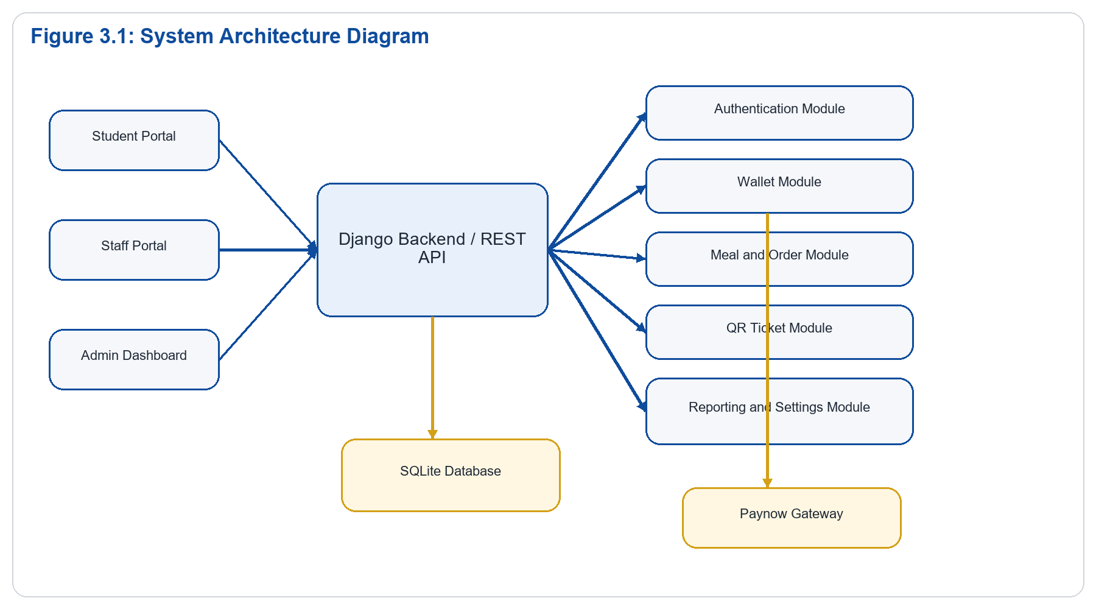
Explanation:
Figure 3.1 shows the overall structure of the HIT Canteen Digital Payment and Meal Verification System prototype. The system is designed around three main user groups: students, staff, and administrators. Each user group interacts with the system through a separate frontend interface that is designed according to its specific role and responsibilities. Although the interfaces are different, all requests from these users are sent to and processed by a single Django backend.
Students use the student interface to register, log in, fund wallets, browse meals, place orders, and access QR tickets for meal collection. Staff members use the staff interface to validate QR tickets, process walk-in orders, top up student wallets, and support daily canteen operations. Administrators use the admin dashboard to manage users, meals, transactions, reports, and system settings. This separation of interfaces improves usability because each user only sees the functions that are relevant to their role.
The Django backend acts as the central processing unit of the prototype. It receives requests from the frontend interfaces, applies the required business rules, and returns appropriate responses. The backend is modularised into several services, including authentication, wallet, order, QR, and reporting services. The authentication service manages registration, login, email verification, and role-based access. The wallet service handles wallet balances, top-ups, and transaction records. The order service manages meal selection, ordering, and pickup slot processing. The QR service generates and validates meal tickets, while the reporting service supports administrative monitoring and analysis.
All these backend services are connected to a central database that provides persistent storage for the system. The database stores user records, wallet balances, meal details, payment transactions, orders, QR tickets, validation history, and reports. By using a central database, the system ensures that information remains consistent across the student, staff, and administrator interfaces. For example, when a student places an order, the order details and QR ticket are stored in the database and can later be accessed by staff for validation.
The system also includes an external integration with the Paynow payment gateway. When a student initiates an online wallet top-up, the backend sends the payment request to Paynow for processing. After the payment is completed, Paynow sends a response or callback to the system, allowing the backend to update the payment status and wallet balance. This makes online payments part of the system while still keeping the core canteen operations under internal control.
However, not all system processes depend on Paynow. QR ticket verification, walk-in order handling, meal management, administrative reporting, and audit monitoring remain internal to the system. This means that staff can still verify tickets and administrators can still monitor operations using records stored in the database. Overall, Figure 3.1 illustrates how the prototype connects users, frontend interfaces, backend services, the central database, and the Paynow gateway into one organised system architecture.

3.2 Module and Component Design
The major modules of the prototype are:

Authentication Module
Handles registration, email verification, login, password change, profile updates, and role-based access control.

Wallet Module
Maintains wallet ownership and tracks all credits and debits using ledger entries. This ensures balances can be audited rather than stored as manually overwritten totals.

Payment Module
Manages online top-up initiation, payment transaction records, provider callbacks, and transaction status updates.

Meal Management Module
Supports meal creation, stock quantity control, active availability, and staff/admin viewing interfaces.

Order Management Module
Allows students to place orders, choose pickup slots, create ticket records, and track order state from payment to service.

QR Verification Module
Generates one-time QR meal tickets and allows staff to scan and redeem them.

Reporting and Monitoring Module
Provides transaction history, daily reconciliation, fraud monitoring, demand forecasting, and summarized admin reporting.
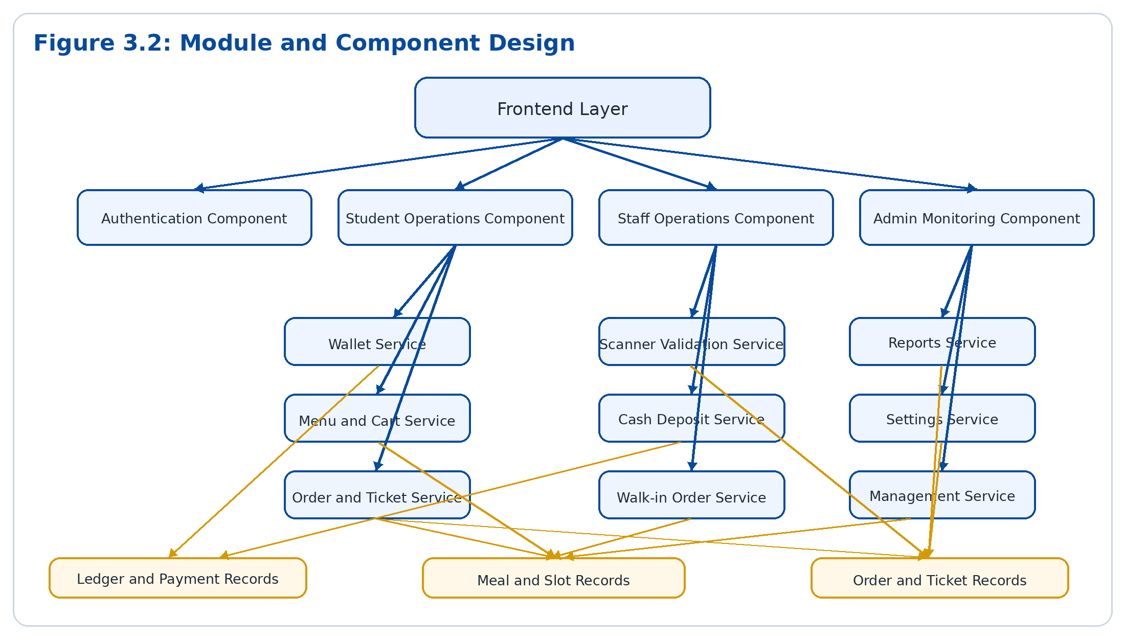
Explanation:
Figure 3.2 presents the functional modules that make up the HIT Canteen Digital Payment and Meal Verification System. The system is divided according to the main user roles, namely students, staff, and administrators. Each role has its own set of functions, which makes the prototype easier to understand, manage, test, and improve.
The student module focuses on the activities performed by students when using the system. It includes wallet management, menu browsing, meal ordering, pickup slot selection, transaction viewing, and QR ticket access. Through this module, students can fund their wallets, view available meals, place orders, and present QR tickets during meal collection. This helps reduce dependence on physical tickets and improves convenience for students.
The staff module supports the daily operational activities performed by canteen staff. It focuses on QR ticket scanning and validation, manual wallet deposits, walk-in order processing, and meal service monitoring. Staff members use this module to confirm whether a student’s QR ticket is valid, used, expired, or invalid before issuing a meal. They can also assist students with cash-based wallet top-ups and process orders for customers who did not pre-book meals.
The admin module provides management and control functions for canteen administrators. It supports user management, meal management, transaction monitoring, system settings, reporting, and analytics. Administrators can use this module to monitor sales, track order volumes, identify popular meals, manage staff access, and review system activity. These functions help improve accountability, planning, and decision-making.
This separation of the system into functional modules improves maintainability because each component has a clearly defined responsibility. For example, wallet-related processes are handled separately from QR validation, while reporting is separated from meal ordering. This makes it easier to identify errors, update specific features, test individual components, and add future improvements without affecting the whole system. Overall, Figure 3.2 shows how the system is organised into clear modules that work together to support efficient, secure, and accountable canteen operations.

3.3 Data Flow Explanation
The main data flows in the prototype are:
The student submits login credentials to the authentication endpoint.
The backend validates credentials and returns a token and role information.
The student loads wallet and menu information from the backend.
When an order is placed, the backend validates balance or payment state, deducts or confirms payment, and creates an order.
The backend generates a QR ticket associated with the paid order.
The staff scanner reads the QR token and submits it to the validation endpoint.
The backend checks ticket status and returns a valid, invalid, or already-used response.
Reporting modules read transactions and orders to produce operational summaries.
Figure 3.3: Context Data Flow Diagram
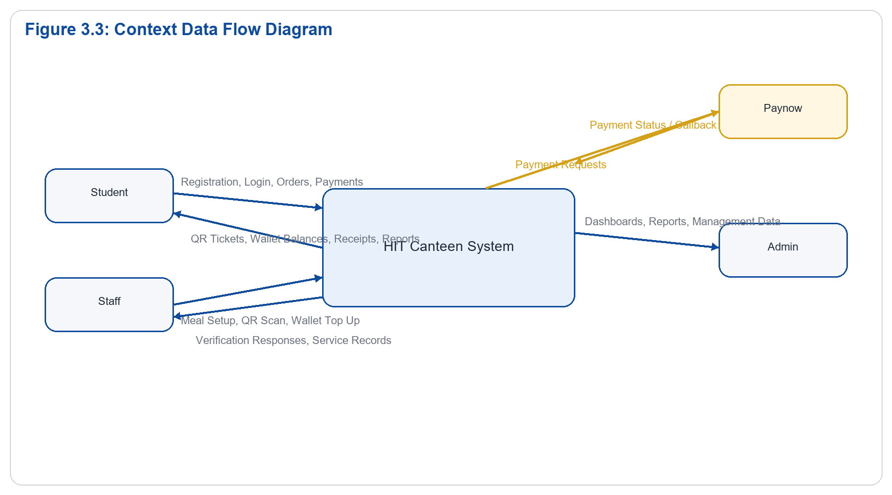
Explanation:
Figure 3.3 presents the context-level Data Flow Diagram (DFD) for the HIT Canteen Digital Payment and Meal Verification System. At this level, the entire system is shown as one central process that receives data from external entities, processes that data, and sends back the required responses. The purpose of the context diagram is to give a simple high-level view of how the system interacts with its users and external payment service without showing the internal processes in detail.
The main external entities shown in the diagram are students, staff, administrators, and Paynow. Students interact with the system by submitting registration details, login details, wallet top-up requests, meal order information, and pickup preferences. In return, the system provides account confirmation, wallet balance updates, meal listings, order confirmations, transaction history, and QR meal tickets for collection.
Staff members interact with the system by providing service-related actions such as QR ticket scans, wallet top-up confirmations, walk-in order details, and meal collection updates. The system responds by showing ticket validation results, updated wallet records, order status, and daily service information. This helps staff confirm whether a meal should be issued and ensures that transactions are properly recorded.
Administrators provide management and oversight actions to the system. These include adding or updating meals, managing users, reviewing transactions, configuring system settings, and requesting reports. The system responds by displaying dashboards, operational summaries, sales reports, user records, and audit information. This supports better monitoring, decision-making, and control of canteen operations.
Paynow acts as the external payment service connected to the system. When a student initiates an online wallet top-up, the system sends payment initiation details to Paynow. Paynow then processes the payment and sends back payment status updates or callback responses. The system uses these responses to update transaction records and wallet balances.
Overall, Figure 3.3 shows that the HIT Canteen system acts as the central point where registration, payment, ordering, verification, reporting, and management data are processed. The context-level DFD clearly identifies the system boundary and shows how data moves between the system and its external entities. This provides a foundation for understanding the more detailed data flow diagrams that describe the internal processes of the prototype.

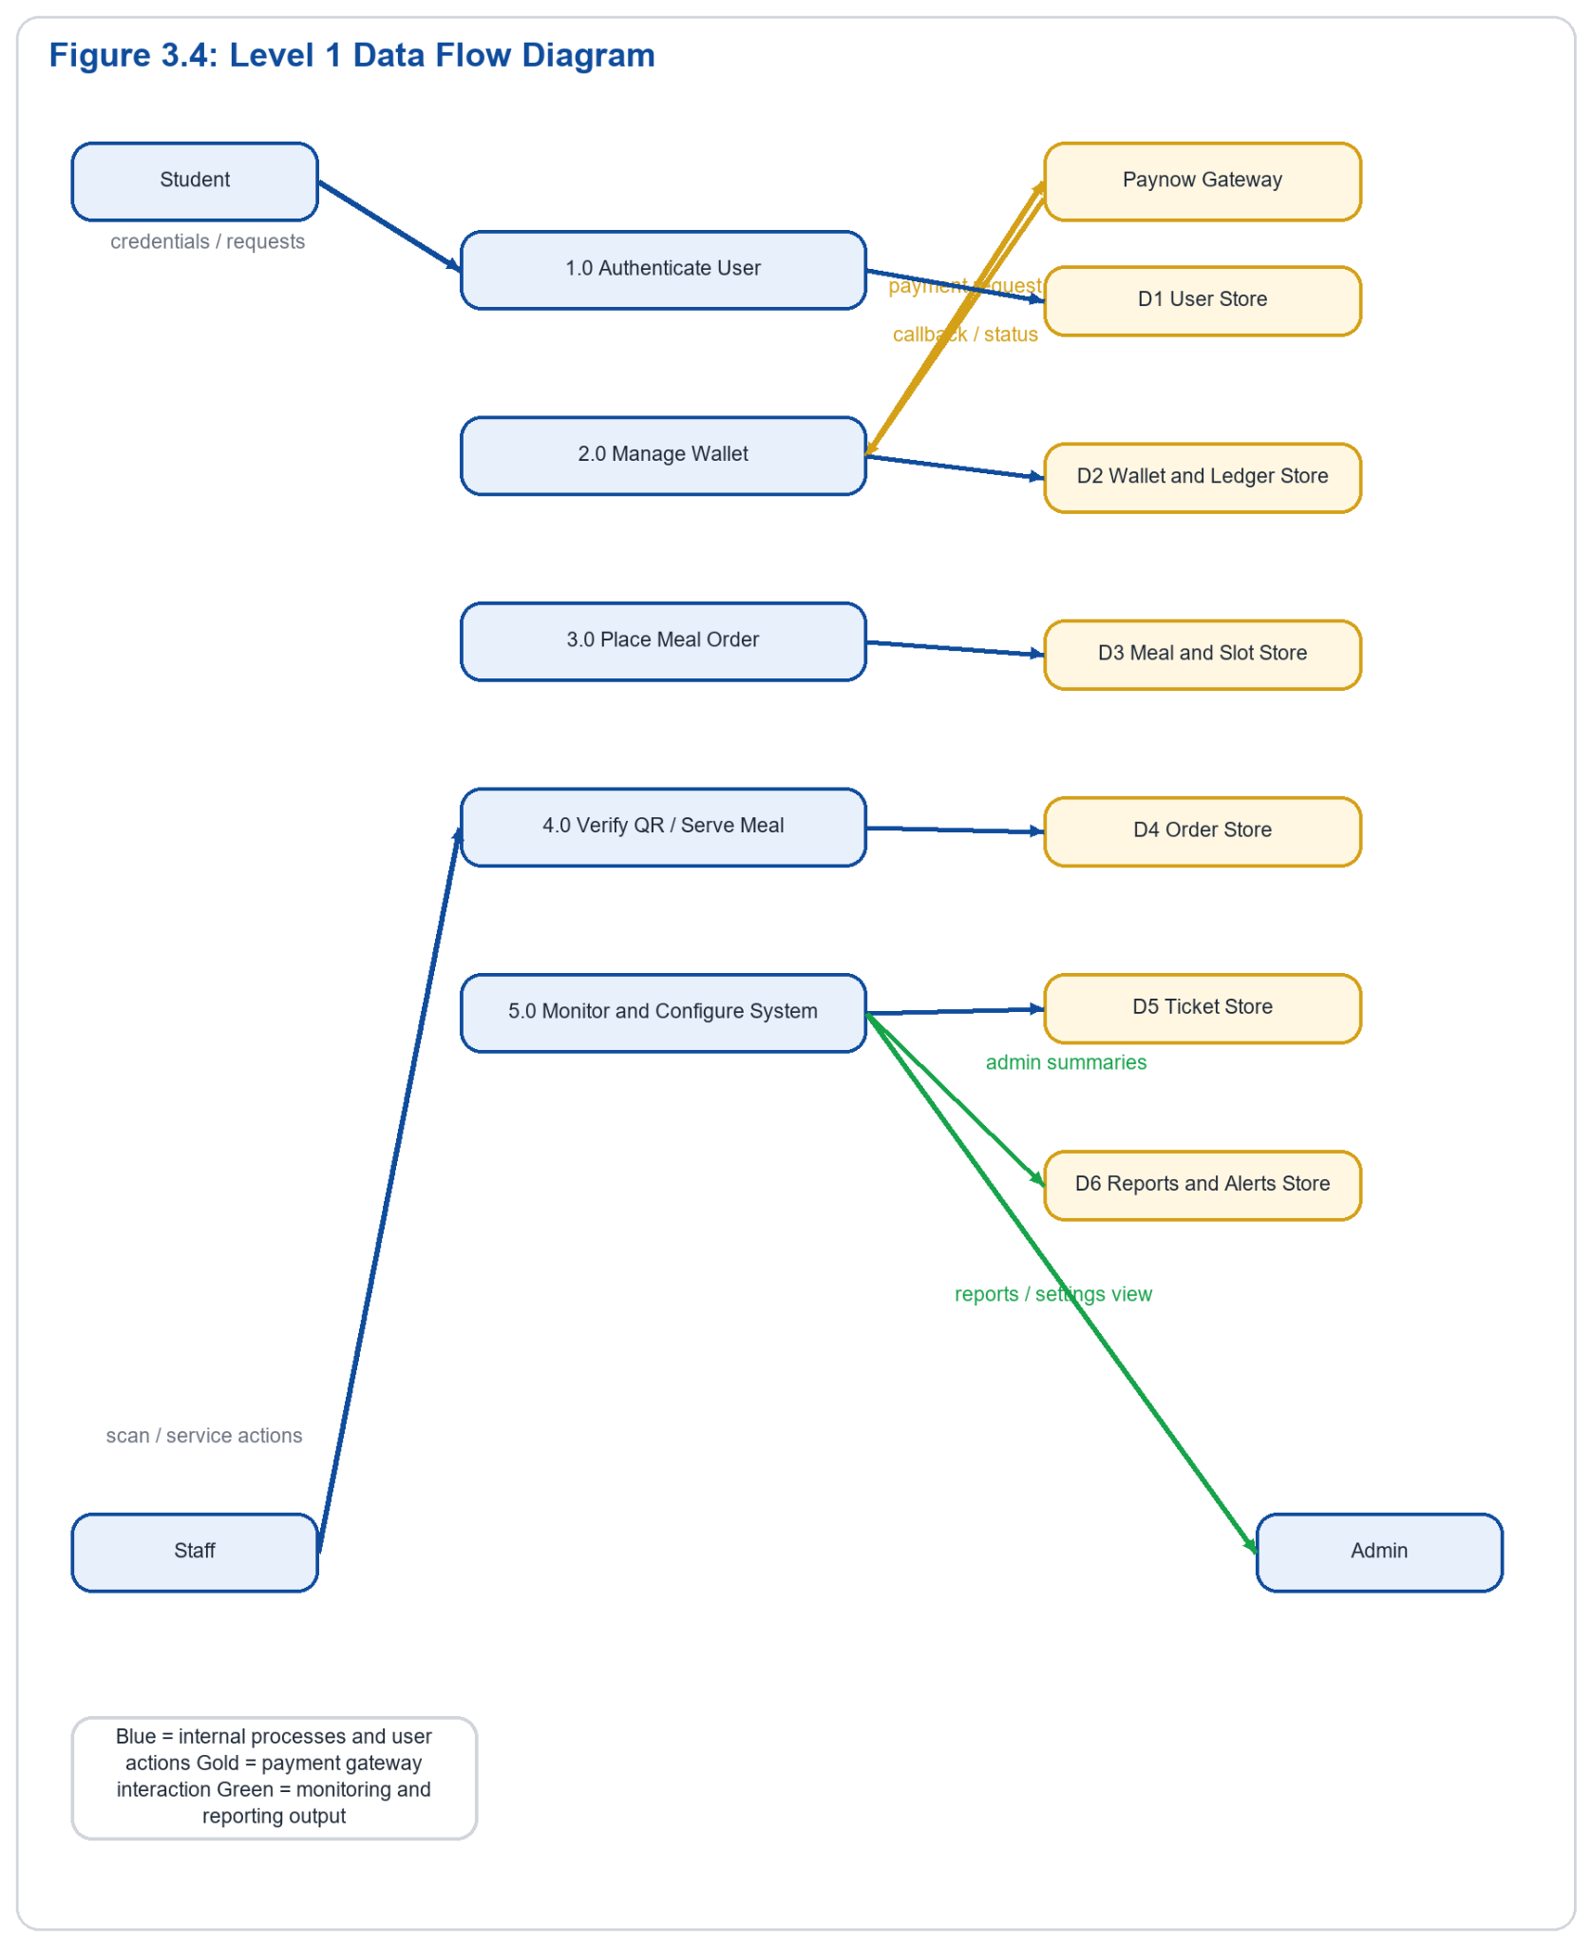
Explanation:
Figure 3.4 presents a detailed Data Flow Diagram of the HIT Canteen Digital Payment and Meal Verification System. Unlike the context-level DFD, which shows the system as one central process, this diagram breaks the system into key operational processes such as authentication, wallet management, order placement, QR ticket validation, and administrative monitoring.
The authentication process manages user access to the system. It reads and writes user information such as registration details, login credentials, email verification status, and user roles. When a student, staff member, or administrator logs in, the system checks their details and directs them to the correct portal based on their assigned role.
The wallet management process handles student wallet balances, top-ups, payments, and transaction records. It tracks all wallet activities using ledger and payment records. When a student initiates an online top-up, the system creates a payment record and connects to Paynow for payment processing. For cash top-ups, staff confirm the payment and update the student’s wallet balance.
The order placement process manages meal selection and purchasing. It uses meal details, prices, availability, and pickup slot information to process student orders. When an order is placed, the system checks meal availability, confirms the student’s wallet balance, deducts the required amount, creates an order record, and generates a unique QR ticket linked to that order.
The staff validation process supports meal collection. Staff scan or enter the QR ticket details, and the system checks the ticket and order records to confirm whether the ticket is valid, already used, expired, or invalid. If the ticket is valid, the meal is issued and the ticket status is updated to prevent reuse.
The administrative monitoring process reads data from major system records, including users, wallets, payments, meals, orders, tickets, and validation logs. Administrators use this information to generate reports, monitor sales, track demand, review transactions, detect irregularities, update meals, manage users, and control system settings.
Overall, Figure 3.4 shows how data moves through the main processes of the system. Authentication controls access, wallet management handles financial records, order placement creates paid meal orders and QR tickets, staff validation confirms meal collection, and administrative monitoring supports reporting and system control. This helps ensure secure, efficient, and accountable canteen operations.

3.4 Use Case Design
The main actors are Student, Staff, and Admin.

Student Use Cases
- Register account
- Verify email
- Log in
- Add money
- View wallet balance
- Browse meals
- Place order
- View transactions
- Show QR ticket

Staff Use Cases
- Log in
- Add meal
- Scan QR code
- Verify meal
- Process walk-in order
- Top up student wallet

Admin Use Cases
- Log in
- Manage students
- Manage staff
- Manage food items
- View transactions
- Generate reports
- Update system settings
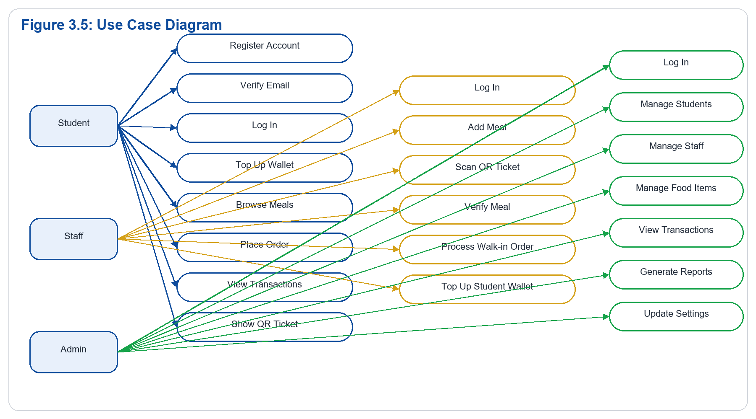
Explanation:
Figure 3.5 summarizes the responsibilities of each user role within the HIT Canteen Digital Payment and Meal Verification System. The system is designed around three main roles, namely students, staff, and administrators. Each role has specific functions and access rights, ensuring that users only interact with the parts of the system that are relevant to their duties.
Students are mainly responsible for account access, payment, ordering, and ticket presentation. They use the system to register, verify their accounts, log in, fund their wallets, browse available meals, place orders, and present QR tickets during meal collection. Their role focuses on making meal purchases easier, faster, and more secure.
Staff members are responsible for service delivery and meal verification. They use the system to validate QR tickets, confirm paid orders, issue meals, process walk-in orders, and assist with wallet top-ups at the counter. Their role ensures that meals are only issued after proper verification and that daily canteen activities are recorded accurately.
Administrators are responsible for oversight, control, and configuration of the system. They manage users, food items, transactions, reports, system settings, and operational rules. They also monitor sales, track meal demand, review system activity, and generate reports for decision-making. This helps improve accountability, planning, and financial control within the canteen.
This separation of responsibilities supports system security because each user group has limited access based on its role. It also improves clarity of operation because students, staff, and administrators each have clearly defined tasks. Overall, Figure 3.5 shows how role-based access helps the system operate in an organised, secure, and efficient manner.

3.5 Database Design
The prototype includes the following major entities:
User: stores email, university ID, full name, role, verification status, and access flags.
Wallet: links each user to a wallet account.
WalletLedgerEntry: stores wallet credits and debits for traceability.
PaymentTransaction: records online and order-related payment flows.
CashDeposit: records staff-assisted cash top-ups.
Meal: stores meal names, descriptions, prices, stock, and active state.
PickupSlot: stores available collection windows.
Order: stores paid meal orders.
MealTicket: stores QR ticket information.
AuditLog: stores traceable system actions.
FraudAlert: stores suspicious activity notices.
DailyReconciliationReport: stores summarized financial and service data.
AdminSetting: stores configurable system options.
The database design supports a normalized and traceable transaction flow suitable for a prototype with audit requirements.
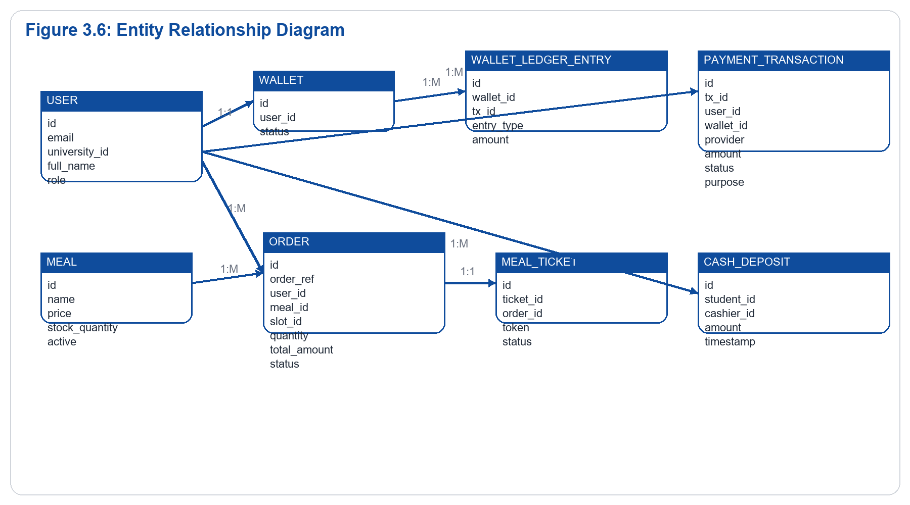
Explanation:
Figure 3.6 shows the main database relationships used in the HIT Canteen Digital Payment and Meal Verification System. The database is designed to connect users, wallets, transactions, meals, orders, pickup slots, and QR tickets in a structured way. These relationships allow the system to keep accurate records of payments, meal orders, and meal collection activities.
Each user owns one wallet, which stores the user’s available balance. The wallet is connected to multiple ledger entries, meaning every wallet activity is recorded separately. These ledger entries may include wallet top-ups, meal payments, deductions, refunds, or corrections. This makes it possible to trace how money enters and leaves a student’s wallet.
Orders are linked to users, meals, and pickup slots. This means that every order shows who placed it, what meal was ordered, and when the meal should be collected. Linking orders to pickup slots helps the canteen manage queues and plan meal preparation more effectively. It also allows staff to confirm whether a student is collecting a meal at the correct time.
Each completed order generates one meal ticket. The meal ticket contains a unique QR code that is linked to the specific order. During meal collection, staff validate the QR ticket to confirm that the order is paid, valid, unused, and connected to the correct student and meal. Once the ticket is used, its status is updated to prevent duplication or reuse.
Payment transactions and cash deposits provide financial traceability. Online payments are recorded as payment transactions, while staff-assisted cash top-ups are recorded as cash deposit records. This helps administrators monitor all forms of wallet funding and reduces the risk of unrecorded payments or financial errors.
Overall, this database structure supports accountability, QR verification, fraud prevention, and reporting. By linking users, wallets, orders, payments, tickets, and meals, the system creates a clear audit trail for canteen operations and helps administrators make informed decisions based on reliable data.

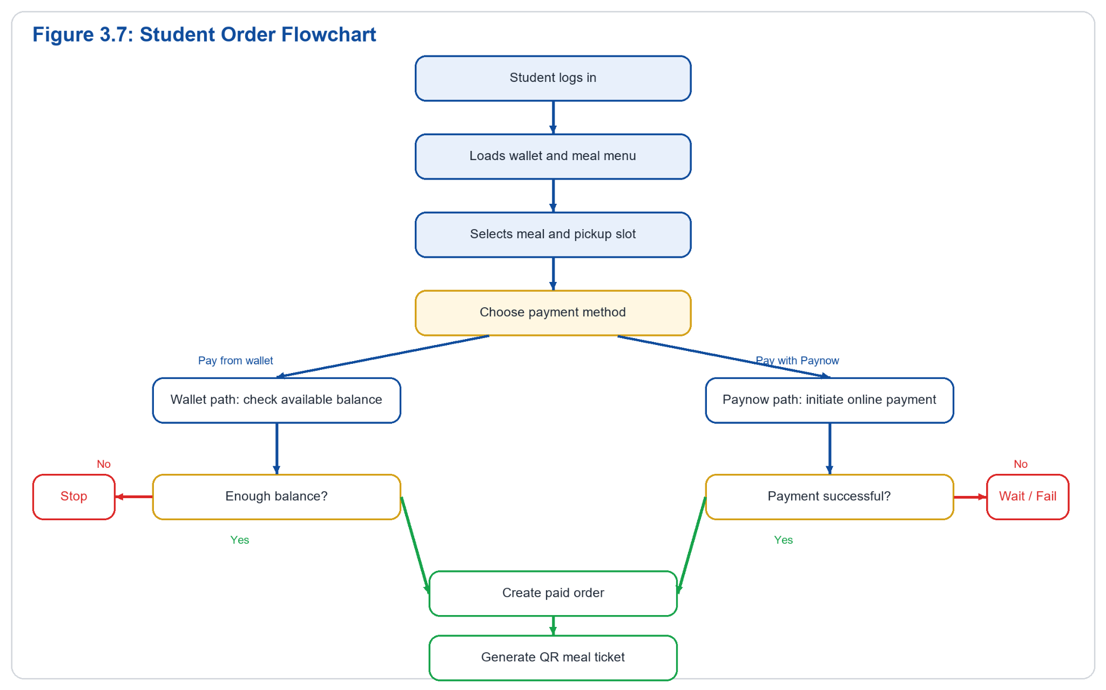
Explanation:
Figure 3.7 shows the operational flow of the HIT Canteen Digital Payment and Meal Verification System from the student’s perspective. It explains the steps a student follows from logging into the system up to receiving a QR ticket for meal collection. This flowchart is important because it shows how the wallet, payment, ordering, and ticketing processes are connected in one continuous process.
The process begins when the student logs into the system using their registered account details. If the login details are correct, the student is directed to the student dashboard, where they can view available meals, check prices, view wallet balance, and start the ordering process. If the login details are incorrect, access is denied until the correct details are entered.
After logging in, the student selects a meal from the available menu. The system displays meal information such as meal name, price, availability, and pickup options. The student then chooses a pickup slot, which helps the canteen manage meal collection times and reduce long queues during peak periods.
The student then chooses a payment path. If the student has enough money in the wallet, the system deducts the meal amount directly from the wallet balance and confirms the order. If the wallet balance is insufficient, the student is required to top up the wallet before completing the order. The top-up may be initiated online through Paynow or supported manually by staff at the counter.
Once payment is successful, the system creates the order and generates a unique QR code linked to that specific meal purchase. The QR ticket acts as proof of payment and is displayed to the student for meal collection. During collection, the student presents the QR code to staff for validation before the meal is issued.
Overall, Figure 3.7 clearly shows how the student moves from account access to meal selection, payment, order confirmation, and QR ticket generation. This flow improves convenience for students, reduces dependence on manual tickets, and ensures that every meal collected is connected to a verified payment record.

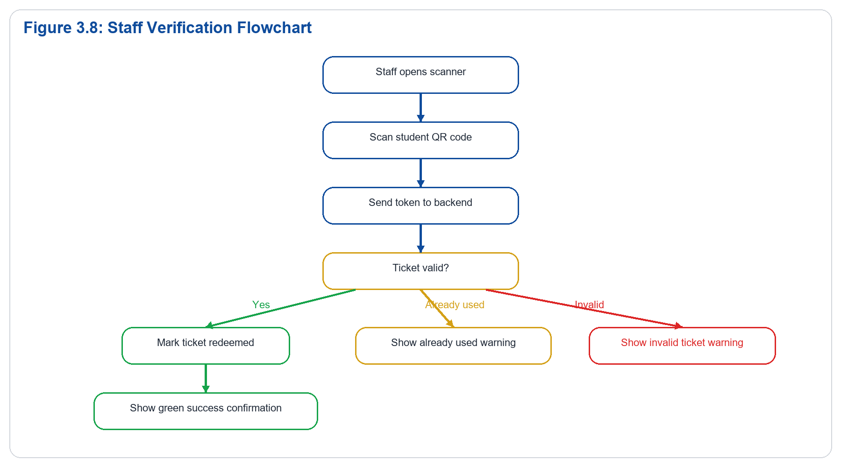
Explanation
Figure 3.8 shows the meal verification process from the staff side of the HIT Canteen Digital Payment and Meal Verification System. This process begins when a student presents a QR meal ticket at the canteen collection point. The staff member scans the QR code using the staff interface, and the encoded token is sent to the backend for validation.
Once the token reaches the backend, the system checks the ticket record stored in the database. It verifies whether the ticket exists, whether it belongs to a completed and paid order, whether it is still within the valid pickup period, and whether it has not already been used. This ensures that only genuine and active QR tickets are accepted during meal collection.
If the QR ticket is valid, the system immediately redeems the ticket by changing its status from unused to used. The staff member is then allowed to issue the meal to the student. This one-time redemption process is important because it prevents the same QR code from being scanned and used again to collect another meal.
If the ticket is invalid, expired, unpaid, or previously used, the system rejects the request and displays an appropriate message to the staff member. This helps staff quickly identify duplicated tickets, reused tickets, or attempted unauthorized meal collection.
Overall, Figure 3.8 shows how the system strengthens meal verification by connecting QR scanning, backend validation, database checking, and ticket redemption. The one-time redemption logic improves accountability, reduces ticket duplication, and ensures that each paid order results in only one meal collection.
n:
____________________________________________________________

4. Technologies and Tools Used

4.1 Programming Languages
The prototype was built using:
- Python for backend logic
- JavaScript for frontend interaction
- HTML for page structure
- CSS for styling

4.2 Frameworks and Libraries
The main frameworks and libraries are:
- Django for the web backend
- Django REST Framework for API endpoints
- Simple JWT for token-based authentication
- qrcode utilities for QR generation
- html5-qrcode for browser-based scanning
- Tailwind CSS and custom CSS styles for responsive presentation

4.3 Development Tools
The development tools used include:
- Visual Studio Code
- PowerShell terminal
- Browser developer tools
- ngrok for public callback URL testing

4.4 Database System
SQLite was used during development because it is lightweight, easy to configure, and appropriate for a working prototype.

4.5 Justification of Technology Choices
Django was selected because it provides rapid development, strong security defaults, and a structured model-view architecture. Django REST Framework was chosen to simplify API construction and role-based responses. JavaScript was necessary for dynamic frontend actions such as login flows, wallet actions, cart behavior, and QR scanning. SQLite was suitable for prototype storage, while ngrok provided a practical way to expose local endpoints for gateway callbacks during testing.
____________________________________________________________

5. System Implementation

5.1 Development Methodology
The system was developed using an iterative prototype approach. Core features were implemented first, then refined based on testing and observed user flow issues. This approach supported continuous improvement of login, wallet funding, QR verification, reporting, and role-based navigation.

5.2 Key System Components

User Authentication and Role Handling
The authentication component supports account registration, email verification, secure login, and routing to the correct student, staff, or admin portal based on the returned user role.

Wallet and Ledger Processing
Instead of storing a manually edited balance value, the prototype uses ledger entries to compute wallet balance. This improves accountability because every credit and debit is stored as a transaction event.

Payment and Top-Up Processing
Online payment initiation is handled through Paynow integration, while staff can also perform counter-based cash top-ups. The system records payment status, callback state, and metadata for tracing and recovery.

Meal Ordering and Ticket Issuance
Once a payment is confirmed, the system creates an order and generates a QR ticket linked to that order. The ticket contains a token and a visual QR representation.

Ticket Verification
When staff scan a QR code, the backend validates the token and checks whether it is issued, redeemed, or invalid. Valid tickets are marked as redeemed to prevent duplicate service.

Reporting and Forecasting
The reporting components summarize payments, orders, and service outcomes. The staff-facing forecast tools also estimate meal demand to support preparation planning.

5.3 Major Functionalities Implemented
The major functionalities implemented in the prototype are:
Student registration and email verification
- Unified login with role-based redirection
- Wallet top-up workflow
- Student meal ordering
- QR code generation for paid orders
- Staff QR scanning and meal verification
- Walk-in meal processing
- Cash wallet deposit by staff
- Admin reporting and settings management

5.4 Integration of System Modules
The modules are integrated through backend APIs and shared database entities. Authentication supports all portals. Wallet state supports both top-up and ordering. Orders create tickets. Staff validation updates service state. Admin reporting reads from payments, orders, alerts, and reconciliation records. This integration ensures that one completed action, such as successful payment, becomes available throughout the system.

5.5 Challenges Encountered and Solutions
Several challenges were encountered during prototype development:
- Frontend state inconsistency across pages
This was addressed by standardizing shared JavaScript loading and unifying portal logic.
- Payment callback configuration issues
Public callback URLs were required, and ngro was used for local testing.
- Paynow initiation failure diagnostics
Better validation and logging were introduced so gateway responses could be traced.
- QR page rendering issues
The QR display was corrected by ensuring latest tickets were loaded dynamically.
- Staff scanner reliability
The scanner flow was refined with stronger feedback, state handling, and clear success/failure indications.

5.6 Discussion of Implementation
The implementation demonstrates that a university canteen prototype can be built as a modular, role-based web application. The use of separate student, staff, and admin flows allowed the system to serve operational needs without overloading a single interface. The integration between wallet funding, ordering, and QR verification was a key success in showing end-to-end service delivery.
____________________________________________________________

6. User Interface Design and System Screenshots

6.1 User Interface Design Principles
The prototype was designed using the HIT institutional color identity with blue and gold as dominant accents. The student and staff interfaces follow a mobile-first layout because those users are more likely to access the system during active canteen operations. The admin dashboard is more desktop-oriented to support reporting and management tasks.
The key design goals were:
clarity
speed of operation
minimal clutter
responsive layouts
strong visual distinction between primary actions and secondary information

6.2 Student Interfaces
The student interfaces include:
- login page
- dashboard
- add money page
- meal menu
- cart and checkout
- QR ticket page
- transactions page
- profile page
Each of these interfaces supports straightforward actions such as wallet review, ordering, and ticket display.

6.3 Staff Interfaces
The staff interfaces include:
- staff dashboard
- QR scanner page
- walk-in order section
- wallet top-up section
- meal management section
These screens prioritize fast canteen operations and large touch-friendly controls.

6.4 Admin Interfaces
The admin interfaces include:
- admin dashboard
- student management page
- staff management page
- food items page
- transactions page
- reports page
- settings page
These screens support supervision, analytics, and configuration.

6.5 Screenshot Guidance
In the final report, each screenshot should be inserted as a numbered figure with a caption and explanation. Example:
Figure 6.1: Student Dashboard
This screen displays the student greeting, wallet balance, quick actions, and recent activity. It acts as the main landing page after successful login.
____________________________________________________________

7. System Testing and Evaluation

7.1 Testing Strategies
Three forms of testing were applied to the prototype:
**Unit-oriented testing** for isolated backend functions and validations.
**Integration testing** for payment, ordering, QR generation, and QR verification flows.
**User testing** for basic navigation and task completion across student, staff, and admin roles.

7.2 Sample Test Cases
Test Case ID | Function Tested | Input | Expected Result | Actual Result | Status
TC01 | Student login | Valid student credentials | Student portal opens | Portal opened correctly | Pass
TC02 | Staff login | Valid staff credentials | Staff portal opens | Portal opened correctly | Pass
TC03 | Admin login | Valid admin credentials | Admin dashboard opens | Dashboard opened correctly | Pass
TC04 | Wallet top-up request | Valid amount and email | Paynow request initiated | Redirect link generated | Pass
TC05 | Meal order placement | Valid meal and slot | Order created and paid | Order generated | Pass
TC06 | QR generation | Successful order | QR ticket created | QR displayed | Pass
TC07 | QR verification | Valid QR token | Ticket redeemed | Success response returned | Pass
TC08 | Duplicate scan | Previously redeemed QR | Reject duplicate use | Already used response returned | Pass
TC09 | Cash deposit | Valid student ID and amount | Wallet credited | Ledger and deposit created | Pass
TC10 | Admin reports | Existing transaction data | Reports load | Reports displayed | Pass

7.3 Results and Analysis
Testing showed that the core prototype functions operate as expected under the main user flows. Login, wallet loading, meal browsing, cart handling, QR generation, QR scanning, and administrative reporting all function within the expected role boundaries. Some third-party payment behavior required additional troubleshooting and callback configuration, but the overall system proved capable of supporting the intended operational scenario.

7.4 System Performance and Reliability
The prototype performs reliably in local and guided testing conditions. Because the architecture separates concerns between authentication, wallet management, ordering, and verification, failures in one area are easier to isolate and diagnose. Ledger-based wallet tracking and one-time QR validation improve operational confidence and auditability.
____________________________________________________________

8. User Guide

8.1 Installation and Setup
To run the prototype:
Install project dependencies.
Activate the virtual environment.
Run database migrations.
Start the Django development server.
Open the web interface in a browser.
Use ngrok if public callback URLs are needed for payment testing.

8.2 System Operation and Navigation

Student
The student logs in, views wallet balance, adds money, browses meals, places an order, and presents the generated QR code for verification.

Staff
The staff member logs in, manages meals, scans QR tickets, performs walk-in orders, and tops up student wallets.

Admin
The administrator logs in, reviews reports, manages users and meals, monitors transactions, and updates settings.

8.3 Key Functionalities
The most important system functions are:
student wallet funding
meal ordering
QR ticket generation
QR verification
cash wallet deposit
admin reporting

8.4 Basic Troubleshooting
Common troubleshooting steps include:
Hard refresh the browser if frontend changes are not appearing.
Restart Django after settings or route updates.
Confirm public callback URLs for online payment testing.
Check valid user credentials and role permissions.
Confirm that ticket status has not already been redeemed.
____________________________________________________________

9. Discussion
The prototype demonstrates that a digital canteen system can significantly improve payment handling and meal verification in a university environment. It replaces slow manual workflows with a structured platform that gives each user group tools that match their responsibilities. Students benefit from convenience and faster service, staff benefit from quick verification and clearer workflows, and administrators benefit from traceable records and operational visibility.
One of the strongest design decisions in the prototype is the separation of user responsibilities through role-based interfaces. Another important decision is the use of wallet ledger entries instead of a fragile direct-balance update approach. QR verification also adds practical value because it creates a fast and secure handoff between student payment and staff service delivery.
The prototype remains an academic system and would benefit from further production hardening, but it is already suitable as a functional demonstration of the proposed solution.
____________________________________________________________

10. Conclusion
This report presented the design, implementation, and evaluation of the HIT Canteen Digital Payment and Meal Verification System prototype. The system was developed to address challenges in traditional canteen operations, including slow payment processing, manual verification, weak accountability, and limited administrative insight.
The prototype successfully demonstrates a working digital model involving student wallets, meal ordering, QR ticket generation, staff validation, and administrative monitoring. The architecture, design, and implementation choices show that the proposed solution is appropriate for the identified problem. Overall, the system provides a practical and modern approach to improving canteen services at Harare Institute of Technology.
____________________________________________________________

References
Use Harvard style for all references included in the final version. Typical sources may include:
- Django documentation
- Django REST Framework documentation
- Paynow integration documentation
- QR code library documentation
- Academic sources on digital payment systems and university service automation
____________________________________________________________

Appendices
The appendices should include:
Extended code listings
Additional system screenshots
Configuration details
Sample test data
API request and response examples

